******BMA Scottish GP Committee/ Scottish LMC Update – June 2021**

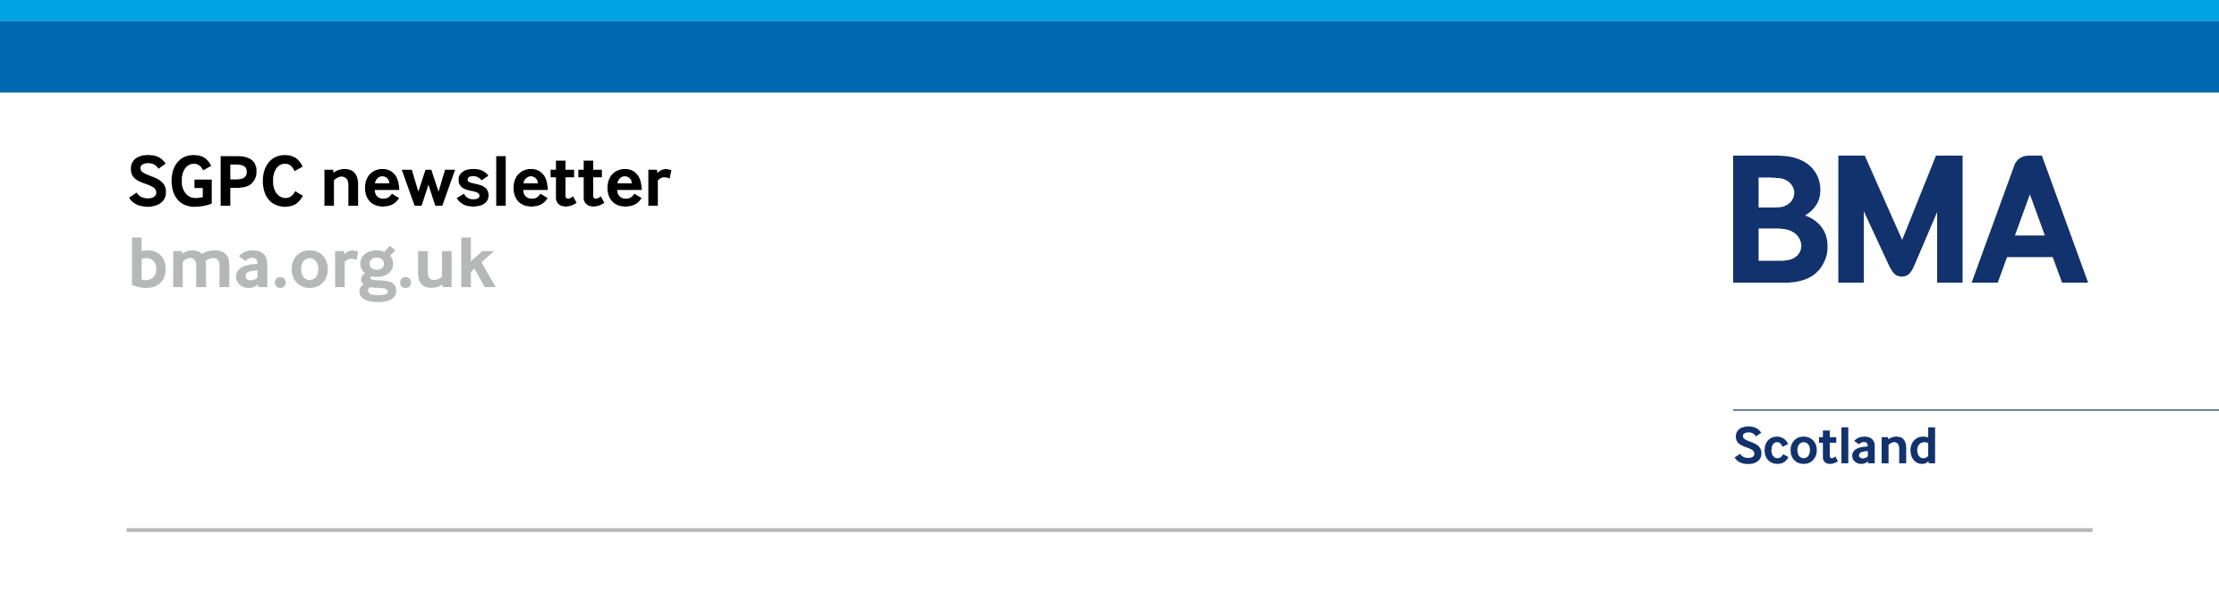

# BMA Scottish GP Committee (SGPC) Update:

## **BMA SGPC Meeting – 17 June 2021**

### Expanded Primary Care Multi-Disciplinary Team Survey

The BMA Scottish GP Committee have launched a survey to aim to understand to what extent GPs have access to the multi-disciplinary team outlined in the GMS contract (2018). The survey is entirely voluntary however we hope to receive a completion from each GP practice. LMCs have also been sent the survey with a request to encourage participation from GP practices. The survey is live and will close on 7 July 2021: <https://www.surveymonkey.co.uk/r/ScotlandMDT>

### BMA SGPC Meeting -17 June

The BMA Scottish GP Committee (SGPC) met on 17 June 2021 and heard updates on development of transitionary services; progress of the memorandum of understanding refresh; results of the snap workload and wellbeing survey and a mention of the expanded multidisciplinary team survey which has recently been disseminated to GP practice and the upcoming elections for all office bearer SGPC posts.

The committee again discussed local rollout of the Redesign of Urgent Care work, the future of COVID-19 community pathways and received various reports from the Sessional GP committee and GP Trainee committee. SGPC also heard updates on premises, IT, GP Wellbeing, medical appraisal and pensions.

### Premises

A National Primary Care (GP) Premises Group meeting was held on 29 April 2021 which discussed priorities for the premises workplan for 2021-22; an update on lease progress and assignation, sustainability loans, premises directions, spending review/ infrastructure, and improvement grants.

## **Negotiating Issues and Contracts**

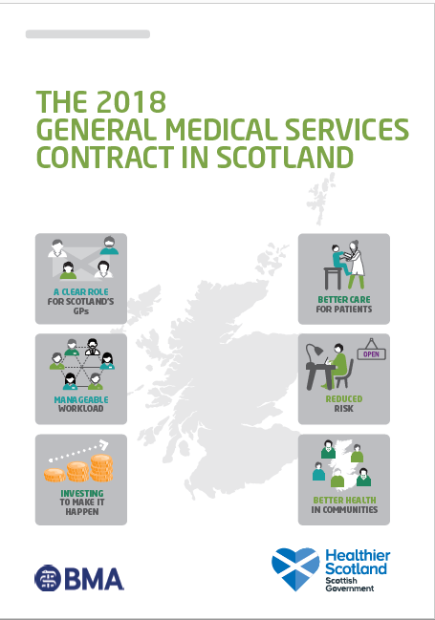

### SGPC/SG Negotiation on MoU and 2018 GMS Contract

BMA SGPC, Scottish Government, Integration Authorities and NHS Boards have been meeting to agree the new updated Memorandum of Understanding which was due to be revised by 1 April 2021. A letter has been issued by Scottish Government on 13 April 2021 to express that the MOU would be updated and issued as soon as possible. However, until that time, the original MoU remains in effect until the updated version is agreed.

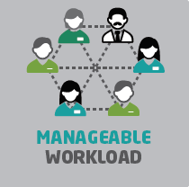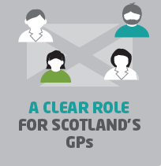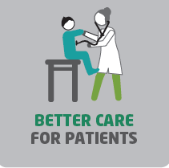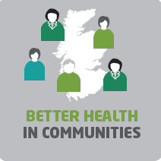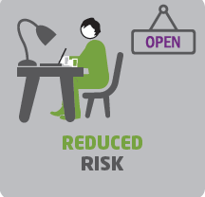

## **Workload and Wellbeing**

**669 responses**

**2 out of 3 GPs describe workload as unmanageable**

**73% reporting negative impact on wellbeing**

**70% more likely to seek early retirement**

**87% of GP and practice staff been subject to physical or verbal abuse from public within last month**

### Snap GP Workload and Wellbeing Survey

BMA Scottish GP Committee ran a short survey in mid-May to get an idea of the current pressures on GPs across Scotland. The information collected will be used to establish the impact that demand is having on GPs and their staff and allow SGPC to push for improvements to help improve the situation for GPs.

### GP and Staff Wellbeing Resources

A reminder that the [Workforce Specialist Service](https://www.practitionerhealth.nhs.uk/accessing-the-service-in-scotland) is available to you. The WSS is delivered by NHS Practitioner Health and is a confidential, multidisciplinary mental health treatment service with expertise in treating regulated health and social services professionals. Please note to access the services you will need to complete a registration form and wellbeing questionnaire to provide NHS Practitioner Health the information they need to support you.   
  
There is also support on the [National Wellbeing Hub](https://www.nationalwellbeinghub.scot) for people working in health and social care, with confidential emotional and psychological support accessible via the helpline **0800 111 4191**.

The BMA also has a host of mental health and wellbeing resources that are confidential and accessible at [bma.org.uk/wellbeingsupport](http://www.bma.org.uk/wellbeingsupport), including a counselling and peer support service which is free, confidential and 24/7 support open to all doctors and medical students (regardless of BMA membership) their partners and dependents on **0330 123 1245.**

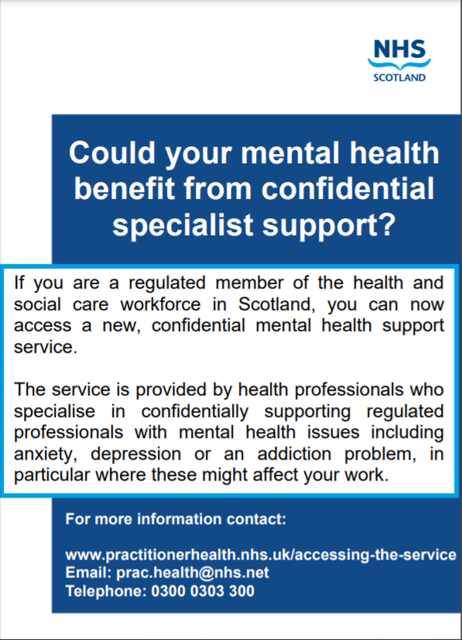

## 

## **COVID-19 Recovery and Remobilisation**

### General Practice Pandemic Recovery in Scotland

SGPC developed the [General Practice Pandemic Recovery in Scotland](https://bmascotlandhome.files.wordpress.com/2021/05/bma-sgpc-gp-recovery-30.03.21.pdf), by request of the outgoing Cabinet Secretary for Health and Sport, Ms Jeane Freeman, for further information and recommended actions to support recovery of general practice from the pandemic in Scotland. We have pressed the Scottish Government to implement the recommendations which include establishing PLT and reflective time for GP practices on a national basis; establishing and continuing with PC/SC interface working in every area. The urgent need for public messaging to help patients understand the current situation on pressures on general practice GP and staff; and promotion of wellbeing services for the GP workforce who are reporting increasing rates of anxiety, depression, stress, burnout, and low morale.

The pandemic has however brought on some positive changes and we sought continuance of the following: GP access triaging, monitoring services in the community, and remote access for GP MDT.   
In relation to structures supporting recovery from COVID-19: the community COVID-19 pathway should persist for as long as necessary by local determination, and the pandemic escalation framework for practices should continue throughout the recovery period.

## **Information Management and Technology**

### Scottish Joint GP IT Group

The twelfth meeting of the Scottish Joint GP IT Group was held on 19 May 2021, with an update on Order Communications, GP IT Re-Provisioning and Docman and presentations from Sam Patel on the National Digital Prescribing and Dispensing Programme led jointly by NES and NSS; Prof Sir Lewis Ritchie on the Primary Care Directorate Data & Intelligence Network; and Jonathan Cameron on the COVID-19 Vaccine Certification Scheme.

SJGPITG also heard updates from the Primary Care Reform Digital Board, NHS Education for Scotland -National Digital Services (NDS), Scottish National Users Group (SNUG), Systematised Nomenclature of Medicine – Clinical Terms (SNOMED-CT), Primary Care Informatics (new SCIMP) and an overview of [Royal College of General Practitioners](https://www.rcgp.org.uk/-/media/Files/RCGP-faculties-and-devolved-nations/Scotland/RCGP-Scotland/2021/9722-RCGP-Scottish-Election-Manifesto-2021.ashx?la=en) and [BMA SGPC](https://bmascotland.home.blog/2021/04/13/general-practice-and-the-election-6-points-for-a-better-future/) published priorities for the next Scottish Parliament for 2021.

The next SJGPITG meeting is scheduled for 29 September 2021.

# 

# LMC Update: For information

### SGPC Representatives, First of Session and Office Bearer Elections for BMA Scottish GP Committee

The election process for deputy chair, co-negotiator, SGPC executive will take place in September in advance of the first of session meeting on 28 October 2021. Any nomination and voting for SGPC representative places on other internal Branch of Practice Committees or places on external groups will run after the first of session meeting.

If your LMC has already elected SGPC representatives for session 2021-22 we would encourage you to send details to Mhairi Weatherston ([mweatherston@bma.org.uk](mailto:mweatherston@bma.org.uk)) our SGPC administrator, at your earliest convenience to ensure inclusion in the elections process.

Newly elected SGPC members for Session 2021-22 are the electorate and eligible nominees for SGPC office bearer – deputy chair, co-negotiator and SGPC executive elections, and will be contacted by secretariat in due course. Dates for next session (2021-2022) is available on the [SGPC webpage](https://www.bma.org.uk/what-we-do/committees/general-practitioners-committee/scottish-general-practitioners-committee).

### Chair Elections for BMA Scottish GP Committee

This year there will be an election for chair of the BMA Scottish GP Committee for a three-session term (2021-24). This will be taking place in July in advance of the last of session meeting on Thursday 19 August 2021.  
The electorate and eligible nominees are the current voting members of SGPC in the 2020/21 session, who will be contacted by secretariat in due course regarding the election.

### 

### SLMC Medical Secretaries Day and SLMC Business Coordinators Day

The Annual Scottish LMC Medical Secretaries Day was held on 21 April 2021, and Scottish LMC Business Coordinators on 14 April 2021.

The business coordinators day discussed implementation of the GMS contract, and COVID-19 pandemic efforts and progress. The following topics were also raised on DVLA, AWI, Guardianship order requests; COVID-19 Certification and Subject Access Requests; and Training funds and opportunities.

The medical secretaries day heard an update from the chair on contract negotiations and COVID-19 progress, and LMC implementation from medical secretaries. There was a topic for supportive peer discussion and reflection; discussion of opportunities for an LMC development project; and discussion of practice manager vocational training scheme and career start funding. An update for the chair of Scottish local medical committee (GP) conference, Denise Mcfarlane; an update from the communications and public affairs lead on the Lobbying act. sustainability loans; discussed recovery and remobilisation challenges and difficulties; and DACS (Digital Asynchronous Consulting Solutions); data protection officers for LMCs.

The date of the next SLMC medical secretaries day is Wednesday 20 April 2022, and the date of the next SLMC Business coordinators day is Wednesday 13 April 2022.

### LMC and GP Subcommittee Board Visits

Due to the impact of COVID-19 the negotiating team have postponed all physical future visits. The negotiating team are however attending virtual meetings. If it would be helpful to meet with the negotiating team virtually please do get in touch.

## Contact us and follow our work

|  |  |  |  |  |  |  |  |  |  |
| --- | --- | --- | --- | --- | --- | --- | --- | --- | --- |
| |  |  |  | | --- | --- | --- | | **Our BMA Scottish GP Committee (SGPC) Negotiating Team** | | | |  |  | C:\Users\patricia\Pictures\.jpg | | ***Dr Andrew Cowie***  ***Deputy Chair, SGPC*** | ***Dr Andrew Buist***  ***Chair, SGPC*** | ***Dr Patricia Moultrie***  ***Deputy Chair, SGPC*** |   **Any emails for the** **BMA Scottish GP Committee negotiating team should be submitted to** [info.gpscotland@bma.org.uk](mailto:info.gpscotland@bma.org.uk) **Your ideas about achievable measures to reduce pressure on general practice are always welcome.  We can’t respond to every email, but all emails are read and considered by the team.** |

### 

### Blogs from our negotiating team:

* [GP survey results hugely concerning](https://bmascotland.home.blog/2021/05/26/gp-survey-results-hugely-concerning/) – 26 May 2021
* [General practice under severe pressure](https://bmascotland.home.blog/2021/05/07/general-practice-under-severe-pressure/) – 7 May 2021
* [General practice and the election – 6 points for a better future](https://bmascotland.home.blog/2021/04/13/general-practice-and-the-election-6-points-for-a-better-future/) – 13 April 2021
* [New specialist service can play a vital role in supporting doctors](https://bmascotland.home.blog/2021/03/29/new-specialist-service-can-play-a-vital-role-in-supporting-doctors/) – 29 March 2021

### Follow the work of the BMA online:

|  |  |
| --- | --- |
| Blog:  <https://bmascotland.home.blog/> | Twitter: [**@BMAScotland**](https://twitter.com/BMAScotland)  <https://twitter.com/BMAScotland> |
| Facebook: <https://www.facebook.com/bmascotland> | Instagram:  <https://www.instagram.com/bmascotland> |

**LMCs are reminded they can contact Andrea Ma, BMA Scottish GP Committee (SGPC) secretariat for more details (**[ama@bma.org.uk](mailto:ama@bma.org.uk)**).**

**BMA Wellbeing Support Services:** **0330 123 1245** | [bma.org.uk/wellbeingsupport](http://www.bma.org.uk/wellbeingsupport) | [@BMAwellbeing](https://twitter.com/bmawellbeing)  
  
Our counselling service is open 24/7 to all doctors and medical students (regardless of BMA membership), plus their partners and dependents, and is confidential and free of charge.